Lab Assignment 9.5
- String Utilities Function:
Consider the following Python function:
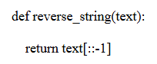
Task:
- Write documentation in:
  - Docstring
  - Inline comments
  - Google-style documentation
- Compare the three documentation styles.
- Recommend the most suitable style for a utility-based string library.
(a) Docstring Documentation:
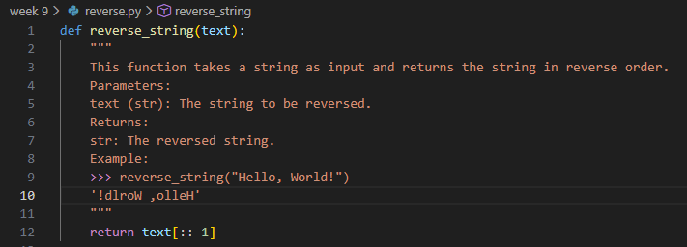
(b) Inline Comments
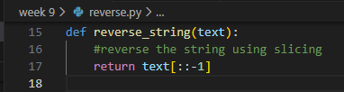
c) Google-Style Documentation
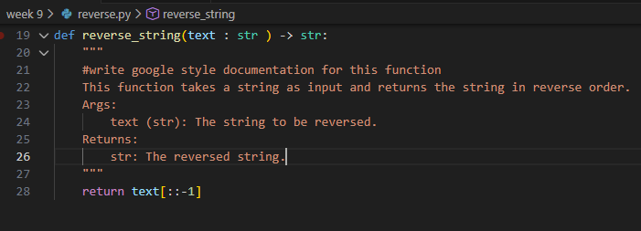
Comparison of Documentation Styles :
Style | Pros | Cons
Docstring | Simple, readable | Less standardized
Inline Comments | Easy to write | Limited explanation
Google-Style | Clear & professional | Slightly verbose

Google-style documentation is best for string utility libraries because it is structured and widely accepted in professional projects

- Password Strength Checker
Consider the function:
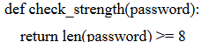
Task:
- Document the function using docstring, inline comments, and Google style.
- Compare documentation styles for security-related code.
- Recommend the most appropriate style.
(a) Docstring
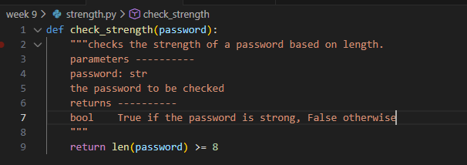
(b) Inline Comments
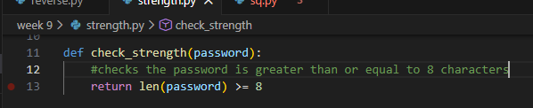
(c) Google-Style Documentation
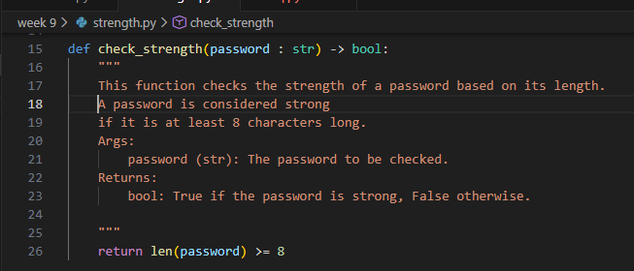

Google-style documentation is best for security-related code, as it clearly explains validation rules and return values

- Math Utilities Module
Task:
- Create a module math_utils.py with functions:
  - square(n)
  - cube(n)
  - factorial(n)
- Generate docstrings automatically using AI tools.
- Export documentation as an HTML file.
> square(n)
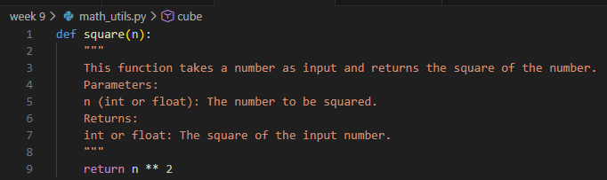
>>> cube(n)
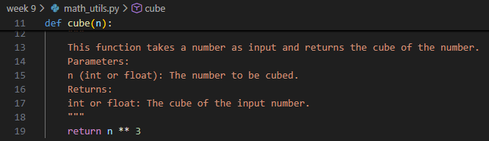

>>> factorial(n)
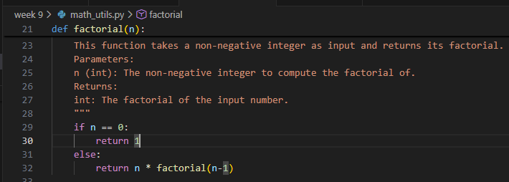
>>
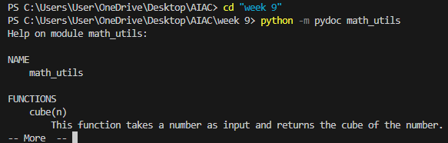
>>
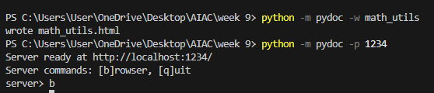
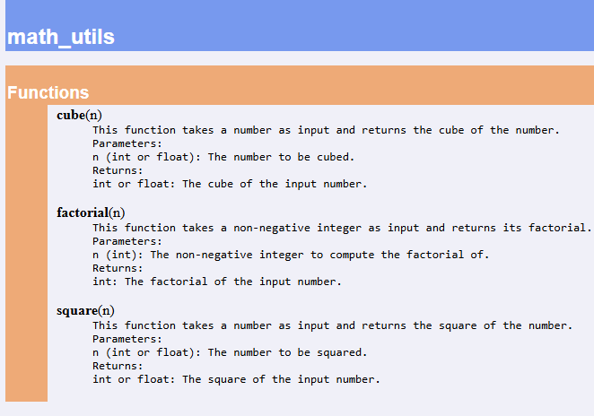

- Attendance Management Module
Task:
- Create a module attendance.py with functions:
  - mark_present(student)
  - mark_absent(student)
  - get_attendance(student)
- Add proper docstrings.
- Generate and view documentation in terminal and browse
>>> mark_present(student)
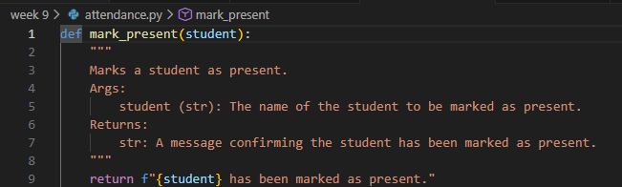
>>> mark_absent(student)
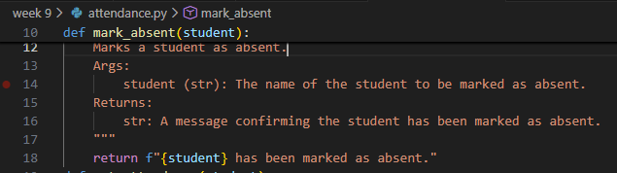
>>> get_attendance(student)
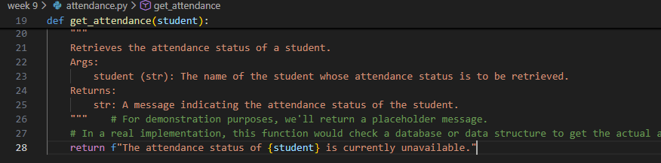
>>>
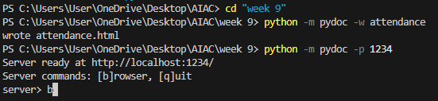
>>>
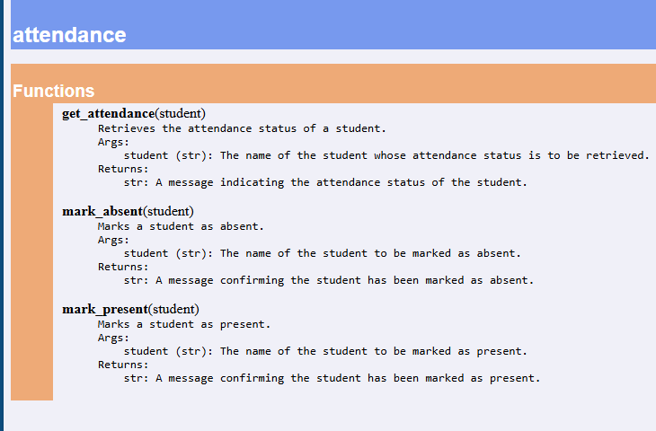
- File Handling Function
Consider the function:
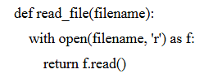
Task:
- Write documentation using all three formats.
- Identify which style best explains exception handling.
- Justify your recommendation.
>>> Docstring
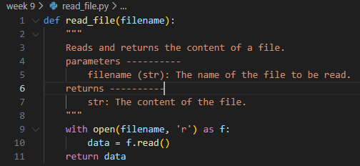
>>> Inline Comments
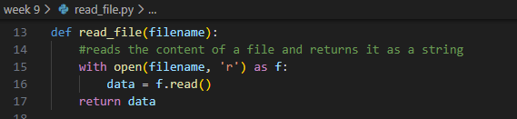
>>> Google-Style Documentation
